DEPARTMENT OF COMPUTER SCIENCE & ENGINEERING

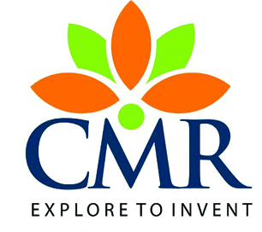

**CMR COLLEGE OF ENGINEERING AND TECHNOLOGY**

##### (An Autonomous Institution under UGC, Approved by AICTE,Accredited by NAAC with ‘A’ Grade)

Kandlakoya, Medchal Road, Hyderabad-5014